Finding CDFIs in Your Community
Using the CDFI Fund List

The US Department of the Treasury oversees Community Development Financial Institutions (CDFI) and maintains a list of certified funds. Finding a CDFI in your community can link you to funding for your business as well as capacity building resources related to financial knowledge and know-how. It can also integrate you and your business into local networks. Keep reading to learn more about CDFIs or scroll towards the bottom of the page for directions on how to use the CDFI Fund List to find those in your community.

What is a CDFI?
Community Development Financial Institutions are nonprofit lenders that provide a range of personal and commercial financial products. They have a mission to fill gaps in access to capital for businesses that are owned by women, by people of color, or by people with lower credit scores or insufficient credit history. CDFIs serve economically distressed communities.

Why should I consider a CDFI?
There are many benefits to working with a CDFI. They are willing to
- Approve smaller loans or lines of credit that traditional banks normally do not
- Offer lower interest rates than other alternative (non-bank) lenders
- Work with borrowers who have lower credit scores or insufficient credit histories
- Work with newer businesses that do not have a long revenue history
- Help the borrower repair credit and build financial literacy
- Connect you with other sources of financing as needed
- Connect you with local small business and capital networks

How do I find a CDFI that serves my community?
The file named “Find a Certified CDFI” in iConnect Resources contains a list of certified CDFIs.

To find the CDFIs in your area, look for the name of your state or territory in column A and click the “+” sign to the left and down one row to expand the list for the state you want. For example, if you want to expand the list for Colorado, click the “+” next to Connecticut.
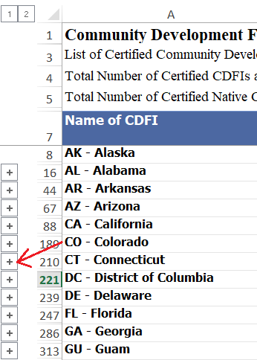
When you are done browsing the CDFIs in Colorado, clicking the “-“ will collapse the Colorado list.

You can expand as many states and territories as you want to by clicking the “+” signs. Just remember that the “+” for the state/territory you want is to the left and down one row.

You can expand all the states and territories by clicking the “2” above Row 1 of the spreadsheet. Clicking on the “1” will collapse all the states and territories.

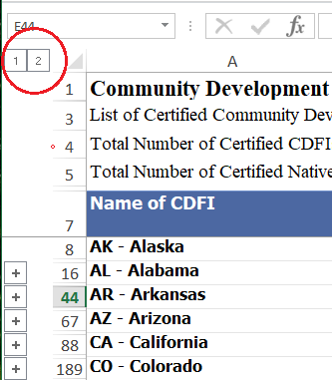

Additional Information about CDFIs and Alternative Lenders
The CDFI Fund Empowering Underserved Communities
https://www.cdfifund.gov/Documents/CDFI_Brochure%20Updated%20Dec2017.pdf

Small Business Guide to Alternative Lending
https://www.business.com/articles/alternative-lending-for-small-business/

Is a CDFI Loan Right for My Business?
https://www.merchantmaverick.com/take-business-loan-cdfi/

